SECTION 035416
HYDRAULIC CEMENT UNDERLAYMENT

PART 1 GENERAL
Provide system of moisture mitigation, surface preparation products, and adhesives from a sole manufacturer necessary to achieve proper installation of specified flooring material that will provide owner with a single source, limited system warranty for a period of no less than 25 years. Add TEC® Flooring Products to this specification for appropriate adhesive application in accordance with 25 Year Moisture Control Limited System Warranty as shown below in section 1.6.
  - SECTION INCLUDES
1.11 Moisture Mitigation Membrane
A. TEC® LiquiDam® two-part,100% Epoxy or TEC® LiquiDam EZ™ 1 part polymeric emulsion
1.12 Trowelable Patches, Skim Coats and Primers
    - TEC® VersaPatch®
    - TEC® Multipurpose Primer
    - TEC® Patch Additive Acrylic Latex
    - TEC® PerfectFinish™ Skim Coat, Underlayment
    - TEC® Fast-Set Deep Patch Underlayment
    - TEC® Floor Patch Pro
    - TEC® Feather Edge Skim Coat
1.13 Self Leveling Underlayments
A. TEC® Level Set® 300 Self-Leveling Underlayment
B. TEC® Fiber-Reinforced Self-Leveling Cement Based Underlayment
C. TEC® Level Set® LW-60 Ultra-Lightweight Self-Leveling Underlayment
1.14 Self Leveling Wear Surface
A. TEC® Ultra Wear Surface / Self-Leveling Cement Based Underlayment
B. TEC® Level Set® Wear Topping
  - RELATED SECTIONS
    - Section 033000 - Cast Underlayment Concrete
    - Section 090000 - Finishes
  - REFERENCES
    - ASTM F 2170 -- Standard Test Method for Determining Relative Humidity in Concrete Floor Slabs Using in situ Probes
    - ASTM F 1869 -- Standard Test Method for Measuring Moisture Vapor Emission Rate of Concrete Subfloor Using Anhydrous Calcium Chloride
  - SUBMITTALS

Submit under provisions of Section 013000.

Manufacturer's MSDS and Product Data Sheets on each product to be used, including:
      - Surface preparation instructions and recommendations.
      - Storage and handling requirements and recommendations.
      - Installation methods.

  - QUALITY ASSURANCE
    - Manufacturer Qualifications: Firm specializing in manufacture of cementitious underlayments and toppings, with minimum 5 years’ experience
    - Installer Qualifications: Firm specializing in installation of cementitious underlayments and toppings, with minimum 5 years documented experience with projects of similar scope, design, and materials. Installation of the HB Fuller Construction products must be completed by a factory-trained applicator, INSTALL Substrate Prep Certified Installer, or equal, using mixing equipment and tools approved by the manufacturer.
  - WARRANTY
      - TEC®
H.B. Fuller Construction Products Inc. (“HBF-CP”) warrants, to the owner (“Owner”) of the premises in which the product (“Product”) listed below is applied, that the Product, when installed as a complete system1 (“System”), will, for 25 YEARS: • reduce the moisture vapor emissions of LiquiDam™ or LiquiDam EZ™ treated concrete substrate from a maximum of 25 pounds per 1000 sq. ft./24 hours as determined by the Calcium Chloride Test Method ASTM F1869 (or 100% RH using the Relative Humidity Method ASTM F2170-09) to no more than 3 pounds per 1000 sq. ft./24 hours • if moisture vapor emissions comply with above, and the TEC® products listed in the table below are used as a complete System, the System a) will not fail due to a manufacturing defect, b) will prevent flooring damage and bond failure caused by vapor emissions from the concrete substrate. provided that the Product was properly applied as a System within its applicable shelf life and in accordance with HBF-CP’s written guidelines, Product Data Sheets and Specifications found at tecspecialty.com in effect on the date of its application and consistent with all applicable building codes and industry standards and guidelines, including the TCNA Handbook when applicable, and procedures for professional application to the extent they are consistent with HBF-CP’s written guidelines and specifications

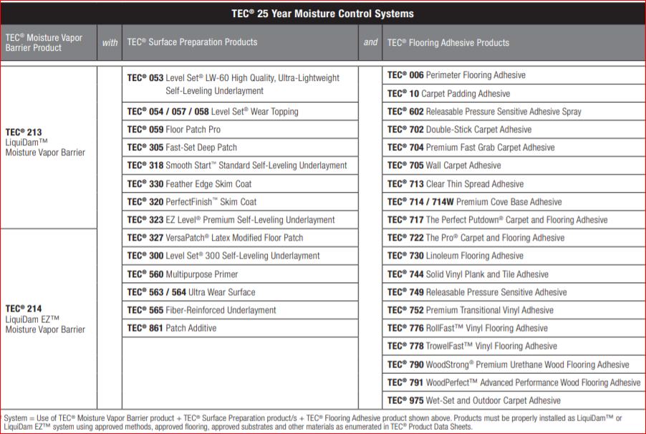

  - DELIVERY, STORAGE, AND HANDLING
    - Comply with requirements of section 01650 and section 01660.
    - Store products in manufacturer's unopened packaging until ready for installation.
    - Store products in a cool dry place out of direct sunlight.
    - Maximum shelf life is 6 months from date of manufacture in unopened containers.
  - PROJECT CONDITIONS
    - For interior application only.

Do not install below 50 degrees F substrate temperature.
    - Not for use in conditions of hydrostatic pressure or excessive moisture (as listed on each surface preparation product’s Product Data Sheet) per ASTM F2170 and/or ASTM 1869. Readings above underlayment’s maximum moisture limit, up to and including 100% RH (or 25 pounds per 1000 sq. ft. per 24 hours) require application of TEC® The LiquiDAM™ (EZ) moisture mitigation membrane. Readings above flooring manufacturers recommended levels also require use of moisture mitigation membrane.

PRODUCTS
  - MANUFACTURERS
    - Acceptable Brand/Manufacturer: TEC® / H.B. Fuller Construction Products Inc.; 1105 S. Frontenac Street, Aurora, IL 60504.
Tel: 800-832-9023. Fax: 800-952-2368. Web: www.tecspecialty.com

** NOTE TO SPECIFIER ** Delete one of the following two paragraphs; coordinate with requirements of Division 1 section on product options and substitutions.
    - Substitutions: Not permitted.
    - Requests for substitutions will be considered in accordance with provisions of Section 01600.
  - MATERIALS – TECHNICAL DATA
    - Concrete Moisture Mitigation vapor barrier: TEC® LiquiDam™ two-part,100% Epoxy or TEC® LiquiDam EZ™ 1-part, polymeric emulsion as manufactured by H.B. Fuller Construction Products:
      - Maximum allowable moisture emission rate of concrete shall be 25 lbs. per 1,000 ft2 per 24 hours when measured in accordance with ASTM F 1869, or an RH value of 100% or less when measured in accordance with ASTM F 2170.
      - Permeability per ASTM E96 shall be <0.10
      - Two-part 100% solids epoxy shall meet ASTM F3010 product requirements for moisture mitigation systems under resilient floor coverings
      - When using Liquidam 100% solids epoxy, TEC® Multipurpose Primer is required for most floor coverings before an application of a self-leveling underlayment, trowel applied skim coat or a cement patch, suitable for the intended use.
NOTE: TEC® WoodStrong™ Premium Urethane Wood Flooring Adhesive, TEC® WoodPerfect™ Wood Flooring Adhesive, TEC® Releasable Pressure Sensitive Adhesive or TEC® Clear Thin Spread Adhesive may be applied directly to LiquiDam EZ™ Moisture Vapor Barrier if concrete surface is sufficiently smooth and level to accept flooring. If the substrate is not smooth and level, please treat with appropriate TEC® surface preparation products, for the proposed floor coverings, as noted above.

    - Primer: TEC® Multipurpose Primer. For difficult to bond to substrates. Refer to data sheet for substrate requirements.
      - Primer shall be solvent free; VOC < 10 g/L
    - Additive: TEC® Patch Additive (VCT, embossed resilient floor coverings, or adhesive residue). VOC < 15 g/L
    - TEC® PerfectFinish™ Skim Coat Patch:
      - Compressive Strength shall be no less than 3,600 psi @ 28 days (Air curing samples) when tested in conformance with ASTM C 109 Modified.
      - Patching depth shall be from feather edge to ½”
      - Fast setting - install flooring in as soon as 15-60 minutes
    - TEC® Feather Edge Skim Coat
      - Compressive Strength shall be no less than 3,600 psi @ 28 days (Air curing samples) when tested in conformance with ASTM C 109 Modified.
      - Patching depth shall be from feather edge to ½”
      - Fast setting - install flooring in as soon as 15-20 minutes
    - TEC® Fast-Set Deep Patch Underlayment:
      - Compressive Strength shall be no less than 4,200 psi @ 28 days (Air curing samples) when tested in conformance with ASTM C 109 Modified.
      - Flexural Strength shall be no less than 1,100 psi @ 28 days when tested in conformance with ASTM C 580.
      - Walkable hardness in 60 minutes, apply most floor coverings in 1 to 1-1/2 hours.

Application depth shall be from feather edge to 1 ½ inches per application without the use of aggregate
      - VOC shall be 0 g/L
    - TEC® Level Set® 300 Self-Leveling Underlayment
      - Compressive Strength shall be no less than 5,000 psi @ 28 days (Air curing samples) when tested in conformance with ASTM C 109 Modified.
      - Flexural Strength shall be no less than 1,100 psi @ 28 days when tested in conformance with ASTM C 580.
      - Walkable hardness in 2-4 hours.

Featheredge up to 1-1/2" (up to 2” for Level Set® 300) depth in a single pour, or up to 5" (12 cm) with proper aggregate
      - VOC shall be 0 g/L
    - TEC® Level Set® LW-60 Ultra-Lightweight Self-Leveling Underlayment
      - Compressive Strength shall be no less than 4,000 psi @ 28 days (Air curing samples) when tested in conformance with ASTM C 109.
      - Flexural Strength shall be no less than 1,100 psi @ 28 days when tested in conformance with ASTM C 580.
      - Shrinkage: < -0.07% @ 28 days when tested in conformance with ASTM C 157.
      - Applications from 1⁄4"-2" (6-50 mm) neat and can be featheredged to adjoining elevations
      - 50% lighter than conventional cement and gypsum based systems
      - Walkable hardness in 3-4 hours.

J. TEC® Fiber-Reinforced Underlayment
1. Compressive Strength shall be no less than 6,000 psi @ 28 days (Air curing samples) when tested in conformance with ASTM C 109.
2. Flexural Strength shall be no less than 1,200 psi @ 28 days when tested in conformance with ASTM C 580.

3. Shrinkage: 0.025 - 0.045% @ 28 days when tested in conformance with ASTM C 531 (modified).

4. Ideal Slump range 10.5” - 11.5” (2” diameter pipe, 4” high).

5. VOC content shall be 0 g/L
6 Recycled material shall be 10%.
K. TEC® Ultra Wear Surface/ Underlayment:
1. Compressive Strength shall be no less than 6,000 psi @ 28 days (Air curing samples) when tested in conformance with ASTM C 109.
2. Flexural Strength shall be no less than 1,200 psi @ 28 days when tested in conformance with ASTM C 580.
3. Shrinkage shall be between 0.025 - 0.050% @ 28 days when tested in conformance with ASTM C 531 (modified).

4. VOC content shall be 0 g/L.
5. Recycled material shall be 10%. (gray color only).
NOTE: Requires a topical sealer when used as a wear surface (acrylic, polyurethane or epoxy).

NOTE TO SPECIFIER: Add TEC® Flooring Products to this specification for appropriate adhesive application in accordance with 25 Year Moisture Control Limited System Warranty as above below in section 1.6.

PART 3 EXECUTION
3.1 EXAMINATION

A. Test moisture content of concrete substrate:

1. Per ASTM F 2170, do not install any self leveling underlayments, skim coat or patch if concrete relative humidity is >95% (15 pounds per 1000 sq. ft. per 24 hours per ASTM F 1869) up to and including 100% ( 25 pounds per 1000 sq. ft. per 24 hours per ASTM F 1869) without first applying moisture mitigation vapor barrier, as specified above, to the substrate.

2. For moisture sensitive floor finishes refer to the finish floor manufacturers specifications for moisture limitations. Remediation of excessive moisture conditions must be done prior to installation of underlayment using moisture mitigation vapor barrier moisture mitigation membrane.
a. Notify the Architect and General Contractor in writing of any unsatisfactory conditions.
3.2 PREPARATION
A. Clean surfaces thoroughly prior to installation.
B. Prepare surfaces using the methods recommended by the manufacturer for achieving the best result for the substrate under the project conditions.
1. All surfaces shall be structurally sound and free from oil, grease, dust, loose or peeling paint, sealers, floor finishes, curing compounds or any contaminant that would prevent a good bond.
2. Minimum tensile bond strength of 72 psi (0.5 MPa) is required.
3. Substrate temperature shall be a minimum of 43 degrees F during application.

4. Air temperature shall be maintained above 50 degrees F.
5. For installation over cutback adhesive, remove adhesive by scraping until all that remains is a thin transparent layer of adhesive residue (minimum tensile bond strength of 72 psi ( 0.5 MPa) is required).
6. For installation over gypsum substrates (minimum tensile bond strength of 72 psi (0.5 MPa) is required), prime with Primer; 1 part primer to 3 parts water.
7. For installation over moisture mitigation vapor barrier, prime with Primer used full strength (undiluted).
8. Existing building expansion or control joints must be honored through the patching material.

3.3 MIXING
A. Mix specific material specified in accordance with manufacturer's instructions.

END OF SECTION

