SECTION 090561.13
MOISTURE VAPOR EMISSION CONTROL

PART 1 GENERAL
  - SECTION INCLUDES
    - TEC® LiquiDam™ Moisture Vapor Barrier; two-part 100% solids epoxy
  - RELATED SECTIONS
    - Section 07200 – Thermal and Moisture Protection
    - Section 09000 – Finishes
    - Section 033503 – Moisture Vapor Emission Control
  - REFERENCES
    - ASTM F 1869 Standard Test for measuring Moisture Vapor Emission Rate of Concrete Subfloor Using Anhydrous Calcium Chloride
    - ASTM F 2170 Relative Humidity in Concrete
    - ASTM D 2240, Shore D, Durometer Hardness
    - ASTM D 7234 Tensile Bond Strength
    - ASTM E96 Standard Test Methods for Water Vapor Transmission of Materials
  - SUBMITTALS

Submit under provisions of Section 01300.

Manufacturer's MSDS and Product Data Sheets on each product to be used, including:
      - Surface preparation instructions and recommendations.
      - Storage and handling requirements and recommendations.
      - Installation methods.
  - QUALITY ASSURANCE
    - Manufacturer Qualifications: Company specializing in manufacturing Products specified in this section.
    - A successful application to concrete requires evaluation and preparation to address any conditions that would prevent a good bond.
    - The TEC® LiquiDam™ shall be installed over new or moist concrete (as little as 48 hours old) without the need to mechanically prepare on strong, clean surfaces. Weak or contaminated surfaces must be mechanically prepared by a method such as shot blasting. Mechanically prepared surfaces must have a concrete surface profile of ICRI CSP 2-3 (similar to a light broom finish).
    - Maximum allowable moisture emission rate of concrete at the time of testing: 25 lbs. per 1,000 ft² per 24 hours when measured in accordance with ASTM F 1869, or an RH value of 100% or less when measured in accordance with ASTM F 2170.
    - A TEC® Underlayment must be installed in accordance with the manufacturer’s recommended specifications for use and installation.
    - TEC® LiquiDam™ shall reduce the vapor emissions of the new or moist concrete to less than 3 lbs. and the TEC® underlayment shall be suitable to receive all types of floor coverings when allowed to properly cure in accordance with TEC® recommendations.
    - TEC® LiquiDam™ shall accept most flooring materials in as soon as 4 hours.
    - Limited Product Warranty: Product shall be free from manufacturing defects and will not break down or deteriorate under normal use for 10 years.
    - A TEC® 25 Year System Limited Warranty is available when using specific TEC® LiquiDam™ in conjunction with specific TEC® surface preparation products and adhesives as identified on published warranty at the time of issuance. This warranty warrants to the owner of the premises in which the product is applied, that the products, as indicated on published warranty, when installed as a complete system, will 1) reduce the moisture vapor emissions of LiquiDam™ treated concrete substrate from a maximum of 25 pounds per 1000 sq. ft./24 hours as determined by the Calcium Chloride Test Method ASTM F1869 (or 100% RH using the Relative Humidity Method ASTM F2170-09) to no more than 3 pounds per 1000 sq. ft./24 hours, and 2) if moisture vapor emissions comply with above, and the TEC® products listed in the table below are used as a complete System, the System a) will not fail due to a

manufacturing defect, b) will prevent flooring damage and bond failure caused by vapor emissions from the concrete substrate. See complete details for remedies, exclusions and disclaimer of warranties of most current warranty as published on the TEC® website: http://www.tecspecialty.com/supporting-materials/warranty-info/?lang=English

As of February 2018:
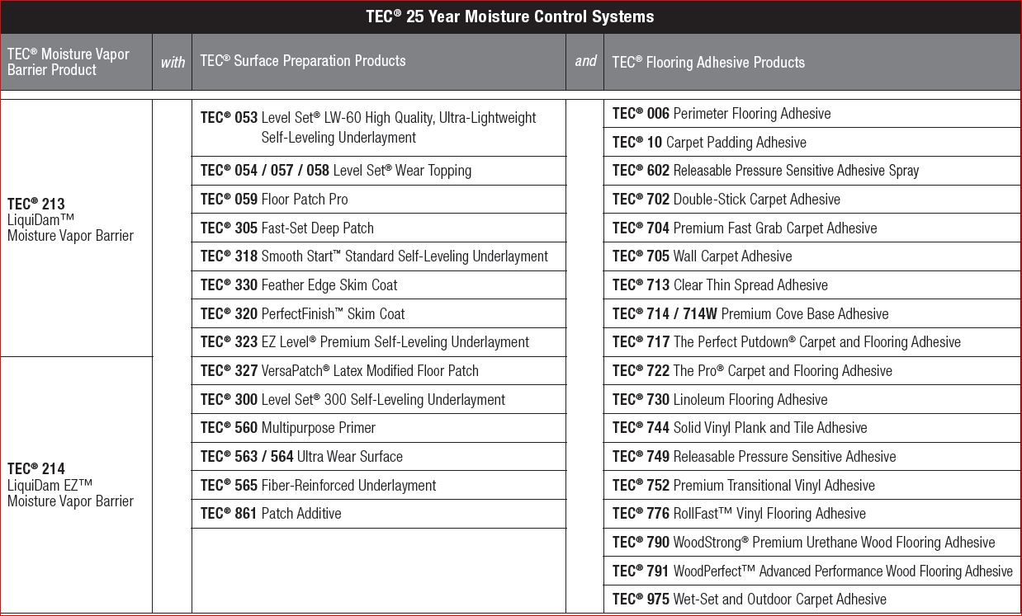

  - DELIVERY, STORAGE, AND HANDLING
    - Comply with requirements of section 01650 and section 01660.
    - Store products in manufacturer's unopened containers until ready for installation.
    - Store products in a cool dry place out of direct sunlight.
    - Maximum shelf life is 1 year from date of manufacture in unopened containers.

  - PROJECT CONDITIONS
    - For interior application only.
    - Do not bridge existing expansion joints.

Do not install in temperatures below 50 degrees F.
    - Not for use in conditions of hydrostatic pressure or excessive moisture (>100% Relative Humidity) per ASTM F 2170, or 25 lbs./
1000 sq. ft. / 24 hours per ASTM F 1869.

PRODUCTS
  - MANUFACTURERS
    - Acceptable Brand/Manufacturer: TEC®/H.B. Fuller Construction Products Inc.; 1105 S. Frontenac Street, Aurora, IL 60504.
Tel: 800-832-9023. Web: www.tecspecialty.com

TEC® LiquiDam®

** NOTE TO SPECIFIER ** Delete one of the following two paragraphs; coordinate with requirements of Division 1 section on product options and substitutions.
    - Substitutions: Not permitted.
    - Requests for substitutions will be considered in accordance with provisions of Section 01600.
  - MATERIALS
    - The TEC® LiquiDam™: Technical Data:
      - Maximum allowable moisture emission rate of concrete: 25 lbs. per 1,000 ft² per 24 hours when measured in accordance with ASTM F 1869, or an RH value of 100% or less when measured in accordance with ASTM F 2170.
      - Permeance shall be less than 0.10 perms per ASTM E96
      - Hardness: 60 when tested in conformance with ASTM D 2240.
      - Floor covering installation: 4 hours (dependent on substrate conditions, porosity and temperature.
      - Two-part; 100% solids epoxy
      - VOC: 0 g/L (Part A and Part B mixed)
    - Most floor coverings will require an application of a self-leveling underlayment or a trowel applied skim coat, which shall be TEC® PerfectFinish™ (no primer required) or a TEC® Level Set 300 self-leveling underlayment (TEC® Multipurpose Primer required), suitable for the intended use.
NOTE: TEC® WoodStrong™ Premium Urethane Wood Flooring Adhesive, TEC® Releasable Pressure Sensitive Adhesive or TEC® Clear Thin Spread Adhesive may be applied directly to LiquiDam™ Moisture Vapor Barrier if concrete surface is sufficiently smooth and level. If the substrate is not smooth and level, please treat with appropriate TEC® surface preparation products as noted above.

EXECUTION
  - EXAMINATION

Test moisture content of substrates:

Before applying LiquiDam™, Moisture Vapor Emission Rate (MVER), using “Anhydrous Calcium Chloride” testing per ASTM F1869, must be obtained to determine the Moisture Vapor Emission Rate, or a relative humidity of the concrete must be obtained using ASTM F2170.

Notify the Architect and General Contractor in writing of any unsatisfactory conditions.
  - PREPARATION
    - Clean surfaces thoroughly prior to installation.
    - Prepare surfaces using the methods recommended by the manufacturer for achieving the best result for the substrate under the project conditions.
      - All surfaces shall be structurally sound and free from oil, grease, dust, loose or peeling paint, sealers, floor finishes, curing compounds or any contaminant that would prevent a good bond.
      - Minimum tensile bond strength of 150 psi (1 MPa) is required, when tested per ASTM D 7234 (tensile bond strength).
      - Substrate temperature shall be a minimum of 50°F during application.
      - Air temperature shall be maintained between 50 – 90°F.

    - A successful application to concrete requires evaluation and preparation to address any conditions that would prevent a good bond. The following guidelines are provided to assist in this process. Additional evaluation, testing and/or preparation may be required to ensure the above Surface Preparation Requirements are met. It is necessary to evaluate all four conditions. Check for Condition 1 on the entire concrete surface. Conditions 2 through 4 should be checked for at least once per every 50 ft² (4.6 m²) on small applications (1000 ft² [93 m²] or less) and once every 100 ft² (9 m²) on large applications (greater than 1000 ft² [93 m²]). Once you have completed the preparation method, always re-check to confirm the method worked.
CONDITION 1: Surface coatings and/or contamination such as gypsum plaster, joint compound, paint and adhesive. Evaluation: Look at the surface and note the type and location of the surface contamination. Preparation: First scrape off any lumps and loose material. Then use an appropriate cleaning method for the type of coating or contamination.
        - For gypsum plaster and joint compound — Scrub with warm water and detergent to remove any remaining material. Thoroughly rinse off any residue and allow concrete to dry prior to application of any TEC® materials.
        - For paint — Chemical strippers should not be used. They may leave a residue or be absorbed into the concrete and later migrate into the surface and cause a bond failure. Paint not easily scraped off should be mechanically removed.
        - For adhesive — Scrape off all the adhesive from the surface first, then remove the layer of adhesive-contaminated concrete by mechanical means.
CONDITION 2: Weak top layer (called laitance) or damaged concrete such as spalling, scaling, delaminating or crumbling. Evaluation: First scrape the surface with a knife blade. If this produces a fine powder, then laitance is present. Then use a hammer or other heavy object to sound out weak or hollow areas. Note the areas that are weak or damaged. Preparation: Weak or damaged concrete must be mechanically removed. Do NOT acid wash or etch concrete because it is difficult to fully remove contaminants and properly neutralize. The acid can penetrate into the porous concrete and chemically undermine it, weakening the concrete. Acid washing will not remove grease or oil.
CONDITION 3: Curing Compounds/Sealers
        - Broom finish or Steel troweled finish (non-glossy) Evaluation: Apply water droplets onto the surface. If the droplets are not absorbed within 60 seconds the surface was treated with a curing compound/ sealer or is contaminated. Preparation: The sealed or contaminated layer of concrete must be removed by mechanical means.
        - Burnished finish (glossy surface) Evaluation: Frequently LiquiDam™ can be installed over burnished concrete without mechanical preparation. For glossy burnished concrete surfaces, apply test areas to confirm bond strength of at least 150 psi when tested per ASTM D7234 (tensile bond test). Preparation: Glossy burnished concrete surfaces that do not provide bond strength of at least 150 psi must be removed by mechanical means.
CONDITION 4: Final Surface Preparation - removal of dirt and dust. Evaluation: Wipe the surface with a clean dark cloth. If powder is visible on the cloth the surface is not clean enough. Note the areas that were not clean enough. Preparation: Always use a two-step method to remove surface dirt and dust. First use a dry clean broom and sweep the entire surface. Do not use oil or wax based sweeping compounds. They can leave a film on the concrete surface that will prevent a proper bond. The second step should consist of one of the following:
        - Vacuuming — use a heavy-duty industrial type vacuum to provide a dust-free surface. It may also be necessary to follow vacuuming with a damp sponge wipe to remove residual surface dust.
        - Water cleaning — use a stream of potable water with sufficient pressure to remove dust and dirt. When necessary, also scrub with a stiff bristled brush. Remove all wash water and allow concrete to thoroughly dry.
        - Detergent water cleaning — using a stiff bristled brush or broom, scrub the entire concrete surface with a cleaning product intended for concrete or a solution of at least 4 ounces (113 g) of trisodium phosphate per gallon (3.78 L) of warm water. Before the surface dries, thoroughly flush the concrete with clean potable water to remove all wash water and residue. Allow concrete to thoroughly dry prior to application of any TEC® materials.

  - MIXING
    - Mix materials in accordance with manufacturer's instructions.
      - Pour entire container of LiquiDam™ Part B Curing Agent into the pail containing LiquiDam™ Part A.
      - Mix thoroughly for 3 minutes using a low speed (≤150 rpm) mixer. Do not over mix and avoid using high speed mixing to prevent entraining air. (NOTE: Mixing initiates an exothermic reaction. Blended material left in the mixing container will generate heat and shorten working time.)

  - EXISTING CRACKS
    - For Static Cracks, Cuts or Joints less than 1 mm wide (with no movement): Remove any dirt, debris or existing sealant from cracks and joints. Mix LiquiDam™ per instructions. Treat all static joints with LiquiDam™ by applying material into the joint with a paintbrush to completely coat the walls of the cavity.
    - For Static Cracks / Control Joints 1 mm-3 mm wide (with no movement): Remove any dirt, debris or existing sealant from cracks and joints. Mix LiquiDam™ per instructions. Blend at a 1:1 ratio with fine silica sand. Immediately pour into control joints and cracks, level with concrete surface.
    - For Expansion Joints/Dynamic Cracks (with movement): Remove any dirt, debris or existing sealant from cracks and joints. Treat all dynamic joints with LiquiDam™ by applying a layer into the joint with a paintbrush to completely coat the walls of the cavity. Once cured, fill the joint with sand or backer rod while leaving the top of joint open for proper treatment with sealant.
NOTE: There is a major difference between the proper application of flooring over static vs. dynamic joints, as well as, variations based upon the type of flooring being installed. Please follow appropriate industry standards, as well as flooring manufacturer’s recommendation for treatment of joints.

  - APPLICATION
    - Layout the substrate area into 150 ft² (13.9 m2) “grids” for each 1 gallon (3.78 L) blended kit.
    - Immediately after mixing, pour the blended gallon container of LiquiDam™, across the grid area while spreading with a squeegee or 1⁄16" (1.6 mm) square-notched trowel allowing the LiquiDam™ to saturate the surface.
    - Back roll surface with a 3⁄16" (4.8 mm) nap foam roller to evenly distribute the product. First saturate the roller and then work at a smooth even pace.
    - Do not exceed 180 ft² per gallon.
Curing and Surface Preparation: Most floor coverings and adhesives require the application of a TEC® cementitious underlayment over LiquiDam™. LiquiDam™ cures to a tacky film with no transfer to the touch in as little as 4-5 hours. LiquiDam™ surface must be primed with undiluted TEC® Multipurpose Primer prior to installation of cementitious underlayment. To maximize installation efficiency primer can be applied in as little as 4-5 hours after installation of LiquiDam™. Allow primer to dry and apply appropriate TEC® cementitious underlayment at a minimum thickness of 1⁄8" (3 mm).

END OF SECTION

