SECTION 090561.13
MOISTURE VAPOR EMISSION CONTROL

PART 1 GENERAL
  - SECTION INCLUDES
    - TEC® LiquiDam EZ™ Moisture Vapor Barrier; 1-part, highly-engineered, polymeric emulsion moisture mitigation
  - RELATED SECTIONS
    - Section 07200 – Thermal and Moisture Protection
    - Section 09000 – Finishes
    - Section 033503 – Moisture Vapor Emission Control
  - REFERENCES
    - ASTM F 1869 Standard Test for measuring Moisture Vapor Emission Rate of Concrete Subfloor Using Anhydrous Calcium Chloride
    - ASTM F 2170 Relative Humidity in Concrete
    - ASTM D7234 Tensile Bond Strength
    - ASTM E96 Standard Test Methods for Water Vapor Transmission of Materials
  - SUBMITTALS

Submit under provisions of Section 01300.

Manufacturer's MSDS and Product Data Sheets on each product to be used, including:
      - Surface preparation instructions and recommendations.
      - Storage and handling requirements and recommendations.
      - Installation methods.
  - QUALITY ASSURANCE
    - Manufacturer Qualifications: Company specializing in manufacturing Products specified in this section.
    - A successful application to concrete requires evaluation and preparation to address any conditions that would prevent a good bond.
    - The TEC® LiquiDam EZ™ can be installed over new or moist concrete (48 hours old) without the need to mechanically prepare on strong, clean surfaces. Weak or contaminated surfaces must be mechanically prepared by a method such as shot blasting. Mechanically prepared surfaces must have a concrete surface profile of ICRI CSP 2-3 (similar to a light broom finish).
    - Maximum allowable moisture emission rate of concrete at the time of testing: 25 lbs. per 1,000 ft2 per 24 hours when measured in accordance with ASTM F 1869, or an RH value of 100% or less when measured in accordance with ASTM F 2170.
    - A TEC® Underlayment must be installed in accordance with the manufacturer’s recommended specifications for use and installation.
    - TEC® LiquiDam EZ™ shall reduce the vapor emissions of the new or moist concrete to 3 lbs. and the TEC® underlayment shall be suitable to receive all types of floor coverings when allowed to properly cure in accordance with TEC® recommendations.
    - TEC® LiquiDam EZ™ shall accept most flooring materials in as soon as 4 hours.
    - Limited Product Warranty: Product shall be free from manufacturing defects and will not break down or deteriorate under normal use for 10 years.
    - A TEC® 25 Year System Limited Warranty is available when using TEC® LiquiDam EZ™ in conjunction with specific TEC® surface preparation products and adhesives as identified on published warranty at the time of issuance. This warranty warrants to the owner of the premises in which the product is applied, that the products, as indicated on published warranty, when installed as a complete system, will 1) reduce the moisture vapor emissions of LiquiDam EZ™ treated concrete substrate from a maximum of 25 pounds per 1000 sq. ft./24 hours as determined by the Calcium Chloride Test Method ASTM F1869 (or 100% RH using the Relative Humidity Method ASTM F2170-09) to no more than 3 pounds per 1000 sq. ft./24 hours, and 2) if moisture vapor emissions comply with above, and the TEC® products listed in the table below are used as a complete System, the System a) will not fail due to a manufacturing defect, b) will prevent flooring damage and bond failure caused by vapor emissions from the concrete substrate.

See complete details for remedies, exclusions and disclaimer of warranties of most current warranty as published on the TEC® website: http://www.TECspecialty.com/supporting-materials/warranty-info/?lang=English

As of February 13, 2018:
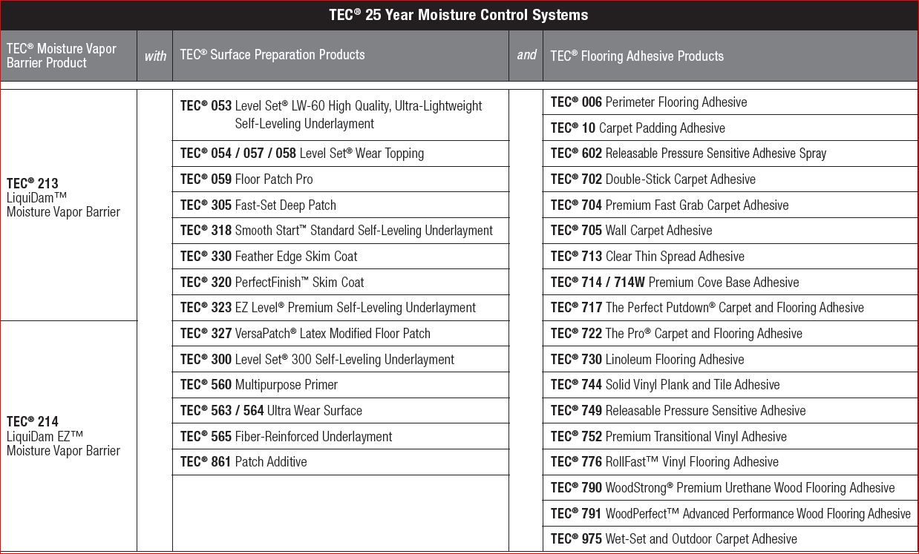

  - DELIVERY, STORAGE, AND HANDLING
    - Comply with requirements of section 01650 and section 01660.
    - Store products in manufacturer's unopened containers until ready for installation.
    - Store products in a cool dry place out of direct sunlight.
    - Maximum shelf life is 1 year from date of manufacture in unopened containers. Uncontaminated, resealed partial pails of product can be stored, until depleted, for up to 6 months.

  - PROJECT CONDITIONS
    - For interior application only.

Do not install over wood products or vinyl.
    - Do not install in temperatures below 50 degrees F.
    - Do not bridge existing expansion joints.
    - Not for use in conditions of hydrostatic pressure.

PRODUCTS
  - MANUFACTURERS
    - Acceptable Brand/Manufacturer: TEC®/H.B. Fuller Construction Products Inc.; 1105 S. Frontenac Street, Aurora, IL 60504.
Tel: 800-832-9023. Web: www.tecspecialty.com

TEC® LiquiDam EZ™

** NOTE TO SPECIFIER ** Delete one of the following two paragraphs; coordinate with requirements of Division 1 section on product options and substitutions.
    - Substitutions: Not permitted.
    - Requests for substitutions will be considered in accordance with provisions of Section 01600.
  - MATERIALS
    - The TEC® LiquiDam EZ™: Technical Data:
      - Maximum allowable moisture emission rate of concrete: 25 lbs. per 1,000 ft2 per 24 hours when measured in accordance with ASTM F 1869, or an RH value of 100% or less when measured in accordance with ASTM F 2170.
      - One-part formula
      - Permeance shall be no greater than 0.10 per ASTM E96
      - Floor covering installation: 4 hours (dependent on substrate conditions, porosity and temperature.)
      - Polymeric emulsion moisture mitigation formula
      - VOC: 1 g/L
    - Most floor coverings will require an application of a self-leveling underlayment or a trowel applied skim coat, which shall be TEC® PerfectFinish™ (no primer required) or a TEC® Level Set 300 self-leveling underlayment, suitable for the intended use. No primer required.
    - TEC® WoodStrong™ Premium Urethane Wood Flooring Adhesive, TEC®® WoodPerfect™ Wood Flooring Adhesive, TEC® Releasable Pressure Sensitive Adhesive or TEC® Clear Thin Spread Adhesive may be applied directly to LiquiDam EZ™ Moisture Vapor Barrier if concrete surface is sufficiently smooth and level to accept flooring. If the substrate is not smooth and level, please treat with appropriate TEC® surface preparation products, for the proposed floor coverings, as noted above.

EXECUTION
  - EXAMINATION

Test moisture content of substrates:

Before applying LiquiDam EZ™, refer to the TEC® Moisture Mitigation Checklist and use an approved testing method to determine the relative humidity of the concrete or Moisture Vapor Emission Rate (MVER). Approved methods include the use of ASTM F2170 to determine the relative humidity of the concrete or “Anhydrous Calcium Chloride” testing per ASTM F1869 to determine the MVER.

Notify the Architect and General Contractor in writing of any unsatisfactory conditions.
  - PREPARATION
    - Clean surfaces thoroughly prior to installation.
    - Prepare surfaces using the methods recommended by the manufacturer for achieving the best result for the substrate under the project conditions.
      - All surfaces shall be structurally sound and free from oil, grease, dust, loose or peeling paint, sealers, floor finishes, curing compounds or any contaminant that would prevent a good bond.
      - Minimum tensile bond strength of 150 psi (1 MPa) is required, when tested per ASTM D7234 (tensile bond test).
      - Substrate temperature shall be a minimum of 50 F during application.
      - Air temperature shall be maintained between 50 – 90 F.

    - A successful application to concrete requires evaluation and preparation to address any conditions that would prevent a good bond. The following guidelines are provided to assist in this process. Additional evaluation, testing and/or preparation may be required to ensure the above Surface Preparation Requirements are met. It is necessary to evaluate all four conditions. Check for Condition 1 on the entire concrete surface. Conditions 2 through 4 should be checked for at least once per every 50 ft2 (4.6 m2 ) on small applications (1000 ft2 [93 m2 ] or less) and once every 100 ft2 (9 m2 ) on large applications (greater than 1000 ft2 [93 m2 ]). Once you have completed the preparation method, always re-check to confirm the method worked.
CONDITION 1: Surface coatings and/or contamination such as gypsum plaster, joint compound, paint and adhesive. Evaluation: Look at the surface and note the type and location of the surface contamination. Preparation: First scrape off any lumps and loose material. Then use an appropriate cleaning method for the type of coating or contamination.
        - For gypsum plaster and joint compound — Scrub with warm water and detergent to remove any remaining material. Thoroughly rinse off any residue and allow concrete to dry prior to application of any TEC® materials.
        - For paint — Chemical strippers should not be used. They may leave a residue or be absorbed into the concrete and later migrate into the surface and cause a bond failure. Paint not easily scraped off should be mechanically removed.
        - For adhesive — Scrape off all the adhesive from the surface first, then remove the layer of adhesive-contaminated concrete by mechanical means.
CONDITION 2: Weak top layer (called laitance) or damaged concrete such as spalling, scaling, delaminating or crumbling. Evaluation: First scrape the surface with a knife blade. If this produces a fine powder, then laitance is present. Then use a hammer or other heavy object to sound out weak or hollow areas. Note the areas that are weak or damaged. Preparation: Weak or damaged concrete must be mechanically removed. Do NOT acid wash or etch concrete because it is difficult to fully remove contaminants and properly neutralize. The acid can penetrate into the porous concrete and chemically undermine it, weakening the concrete. Acid washing will not remove grease or oil.
CONDITION 3: Curing Compounds/Sealers
        - Broom finish or Steel troweled finish (non-glossy) Evaluation: Apply water droplets onto the surface. If the droplets are not absorbed within 60 seconds the surface was treated with a curing compound/ sealer or is contaminated. Preparation: The sealed or contaminated layer of concrete must be removed by mechanical means.
        - Burnished finish (glossy surface) Evaluation: Frequently LiquiDam EZ™ can be installed over burnished concrete without mechanical preparation. For glossy burnished concrete surfaces, apply test areas to confirm bond strength of at least 150 psi when tested per ASTM D7234 (tensile bond test). Preparation: Glossy burnished concrete surfaces that do not provide bond strength of at least 150 psi must be removed by mechanical means.
CONDITION 4: Final Surface Preparation - removal of dirt and dust. Evaluation: Wipe the surface with a clean dark cloth. If powder is visible on the cloth the surface is not clean enough. Note the areas that were not clean enough. Preparation: Always use a two-step method to remove surface dirt and dust. First use a dry clean broom and sweep the entire surface. Do not use oil or wax based sweeping compounds. They can leave a film on the concrete surface that will prevent a proper bond. The second step should consist of one of the following:
        - Vacuuming — use a heavy-duty industrial type vacuum to provide a dust-free surface. It may also be necessary to follow vacuuming with a damp sponge wipe to remove residual surface dust.
        - Water cleaning — use a stream of potable water with sufficient pressure to remove dust and dirt. When necessary, also scrub with a stiff bristled brush. Remove all wash water and allow concrete to thoroughly dry.
        - Detergent water cleaning — using a stiff bristled brush or broom, scrub the entire concrete surface with a cleaning product intended for concrete or a solution of at least 4 ounces (113 g) of trisodium phosphate per gallon (3.78 L) of warm water. Before the surface dries, thoroughly flush the concrete with clean potable water to remove all wash water and residue. Allow concrete to thoroughly dry prior to application of any TEC® materials.
  - MIXING
    - Mix materials in accordance with manufacturer's instructions.
      - Open the pail and hand stir to a smooth creamy consistency with a paint stick or margin trowel. Be sure to re-blend in any liquid that may have separated to the top of the container. Do not use an electric drill and mixing paddle. High-speed drills and paddles can entrain air into the formula. Air entrainment may increase work time to roll out the bubbles. Substrate and all materials must be maintained at 50°F-90°F (10°C-32°C) for 24 hours before, during and after installation.

  - EXISTING CRACKS
    - For Static Cracks, Cuts or Joints less than 1 mm wide: remove dirt, debris or existing sealant from all cracks and joints, then treat static (non-moving) joints, cuts and cracks with LiquiDam EZ™ by directly applying LiquiDam EZ™ into the cracks or joints with a paintbrush, to completely coat the walls of each cavity.
    - For Static Cracks / Control Joints 1 mm-3 mm wide: remove dirt, debris or existing sealant from cracks and joints, then use a concrete crack filler, such as TEC® Feather Edge Skim Coat or TEC® PerfectFinish™ Skim Coat and allow to dry 15 to 60 minutes.
    - For Static Cracks / Control Joints more than 3 mm wide: remove dirt, debris or existing sealant from cracks and joints , then use a concrete crack filler, such as TEC® Fast-Set Deep Patch Underlayment 305 mixed with TEC® Patch Additive 861 and allow to dry 60 to 90 minutes.
    - For Expansion Joints / Dynamic (moving) Cracks: remove any dirt, debris or existing sealant from cracks and joints. Treat all dynamic (movement) joints with LiquiDam EZ™ by applying a layer into the joint edges with a paintbrush to completely coat the walls of the cavity. Once dried, fill the dynamic joint with backer rod, leaving a minimum of 1⁄2" (12 mm) open at the top for proper treatments with a sealant.
  - APPLICATION
    - Lay out the substrate area into one 150 ft2 (13.94 m²) “grid” (6 ft. x 25 ft. / 1.83 m x 7.62 m) to validate the initial gallon spread rate. Depending on the porosity of the substrate, each gallon (3.78 L) will coat an average of 120-150 ft² (11.14- 13.93 m²), per coat.
    - After stirring (as noted above), spread one gallon of the LiquiDam EZ™, across the grid area with a 1⁄16" x 1⁄16" x 1⁄16" (1.6 x 1.6 x 1.6 mm) square-notched trowel. NOTE: Do not exceed 150 ft2 (13.94 m²) per applied gallon. Product must be troweled as the first step and followed up in unison with the quarter inch nap roller.
    - Immediately saturate the roller in the initial application of trowel applied LiquiDam EZ™. Then backroll the area, to optimize disbursement of the material over the entire substrate. Periodically evaluate the surface to ensure a smooth continuous film.
    - Allow to dry a minimum of 90-120 minutes. As the membrane dries it will transition from light blue to dark blue in color. Once the initial coat dries (after 90-120 minutes), the final coat can be applied. Repeat the first coat application steps using the 1⁄16" x 1⁄16" x 1⁄16" (1.6 x 1.6 x 1.6 mm) square-notched trowel, followed up in unison with the quarter inch nap roller. The second coat must fill any remaining white pinholes from the initial coat. Care should be taken to not gouge or otherwise disturb or damage the dried membrane. Inspect the dried film to make sure there are no pin holes, voids, bubbles or breaks in the membrane. Apply additional LiquiDam EZ™ to fill all voids and allow to dry. Do not overwork.
    - The initial application of TEC® LiquiDam EZ™ will require a minimum of 90-120 minutes to dry before a second coat can be applied, depending on ambient conditions. The finished application must cover the substrate completely without any voids or pinholes, to ensure moisture vapor suppression. Once dry, the second coat will appear darker than the first coat. The second coat MUST dry a minimum of 90-120 minutes before moving to the next installation step. After a job is complete, any unused, uncontaminated LiquiDam EZ™ Moisture Vapor Barrier can be simply resealed securely with the container lid, and then can be used for up to 6 months (see storage guidelines).
3.6 DRYING AND SURFACE PREPARATION
A. Most impervious floor coverings require the application of a TEC® cementitious underlayment over LiquiDam EZ™* for the adhesives to bond properly to the floor coverings. Combined coats of LiquiDam EZ™ dry in as little as 3-4 hours, depending on surface porosity and ambient humidity. Apply appropriate TEC® cementitious underlayment directly to the dried LiquiDam EZ™ at a minimum thickness of 1⁄8" (3 mm) (no primer is required). For further information contact your TEC® Sales Associate.
END OF SECTION

